
ATTENDANCE PLAN
Overarching Attendance Objectives and Strategic Priorities
Rationale for prioritising attendance
Garston School firmly believes that regular attendance is crucial for a child’s academic success, social development, and overall wellbeing. Consistent attendance builds
Positive daily habits and routines, promotes strong connections with peers, and ensures students are actively engaged in their learning. Our school’s core values of Respect, Integrity, and Community with the ethos of being the best that you can be, are all underpinned by the fundamental requirement of being present and engaged in the school community.

Links to existing strategic documents
This plan aligns with the school’s Annual Implementation Plan. It supports the school’s commitment to providing a safe, healthy, and innovative learning environment
outlined in our school plans and priorities.
Attendance Policy
Key legal obligations under the Education and Training Act 2020
- Parent/legal guardian obligations: Parents/legal guardians are required to enrol their child at a registered school when they turn 6 years old,
and to make sure their child (including enrolled 5 year olds) attend school every day that the school is open until they are at least 16 years old
- School Board responsibilities: The school Board is required to take all reasonable steps to ensure that students attend when the school is open. The Principal
is responsible for assuring that student attendance is recorded and that absences are notified
Expectations of parents/legal guardians, students and staff in relation to student absences
- Expectations of parents/legal guardians: Parents/legal guardians are expected to notify the school as soon as possible if their child will be
late or absent.These can be logged directly onto our Student Management System (Hero), or via email to classroom teacher. Whānau are also
expected to work with the school to manage any attendance concerns.

- Expectations of students: Students are required to be present and attend class on time. Students are not permitted to leave the school during
school hourswithout permission from a parent/caregiver and the school. If a student needs to leave, they must let their classroom teacher know

- Expectations of staff: Staff are expected to comply with the school and release students at the end of the school day or requested time

Home Learning for Extended Absences
- If a child is absent from school for more than 5 days due to unforeseen circumstances (such as illness, family emergencies,
or other unavoidable events), the school will provide appropriate home learning.This ensures the child remains connected to
their learning, continues to make academic progress, and is supported to transition smoothly back to the classroom upon their return.
Attendance Management Procedures
- Setting expectations: Attendance expectations of families and students are set when students are enrolled at Garston School and reinforced
through our school newsletters and at the start of each term

- Process for recording attendance: Attendance is recorded daily by teachers and staff using official Ministry of Education codes. This data is
stored on our Student Management System and sent to the Ministry, as required by law
- Steps for following up on unexplained absences: School admin or staff follow up with parents/legal guardians about any unexplained absences
- Monitoring practices: The school office is the central point for managing and monitoring attendance. They update records for late arrivals or early
departures and monitor for any concerning patterns. Any staff member can also report attendance concerns to the Principal.
The school analyses trends and may takefurther action if a student’s attendance is concerning. Attendance can be tracked by parents on
Student Management System (Hero).
- Thresholds for identifying concerning absences that require a response are in the table below. Our school uses the Stepped attendance Response
(STAR)
https://www.education.govt.nz/stepped-attendance-response-star to guide when and how we respond to absences.

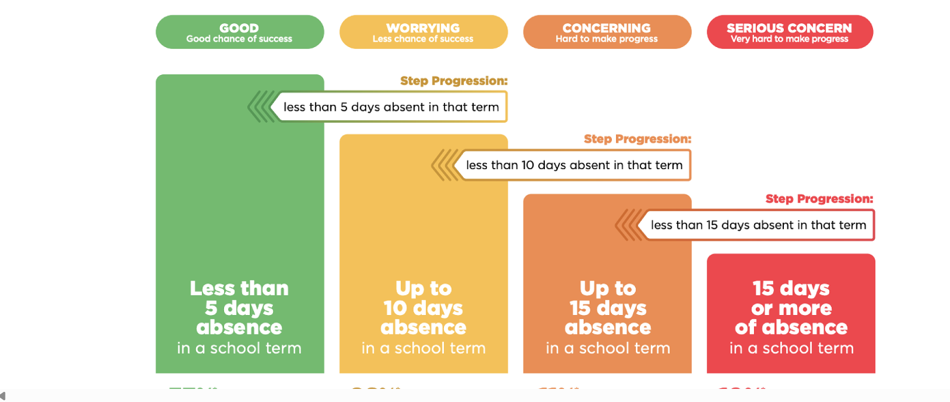

Actions from the school when the child is attending regularly  (less than 5 days absence in a term) | Actions from the school  when the child has some absences  (Up to 10 days absence  In a term) | Actions from the school  when the child has many absences  (Up to 15 days absence  in a term) | Actions from the school  when the child has a lot  of absences  (15 days or more of absence)
Our school will stay in regular  contact with the parent/legal  guardian about the student’s  attendance.  Our school will follow up to find  out the reason why the student is  not at school.  Our school will support students getting to school. | Send a formal notification and contact parent/legal guardian to discuss the reasons for the absence.  Email:  Parent/legal guardian will be notified via direct email of their  child’s weekly attendance rate.  Our school will work with whānau to identify any barriers to attendance.  Use in school resources as appropriate, such as learning support, to remove barriers. | Send escalated formal notification to parents (official attendance letter).  Hold a meeting to analyse reasons for absence and to collaborate on a support plan.  Develop and implement a plan tailored to the reasons and circumstances around the child’s absence (My Every Day Attendance Plan).  Use in school resources as appropriate to remove barriers and request support from Ministry or other agencies as needed. | Send a warning notice and make contact to arrange a meeting with parents/caregiver.  Escalate to a multi-agency response.  Participate in multi-agency response.  Implement and monitor the improvement plan.  Unenroll students as per guidance or for students who will not be returning to school.

Approval: | Date:  Presiding Member: | Published on: | https://www.garston.school.nz/
Effective Date: | January 2026 | Review Date:

